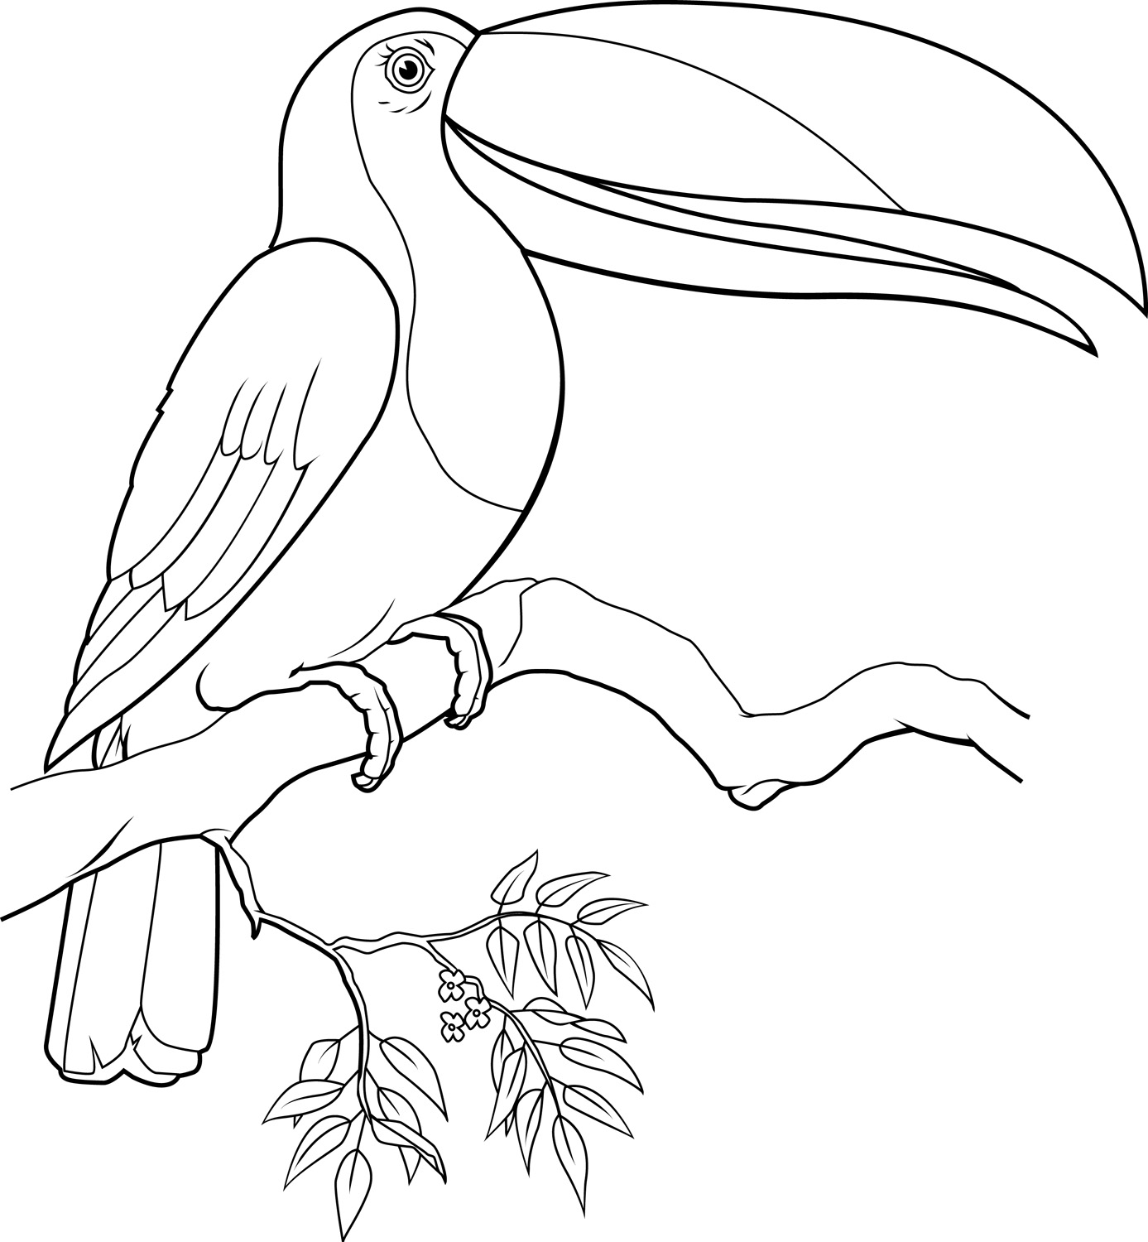
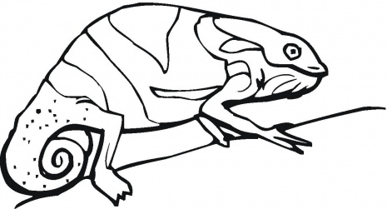
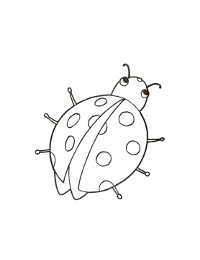
Colourful Animals

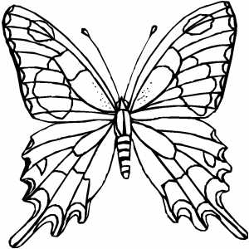
Write the names and colour.
………………………………………….………………………………………….

………………………………………………….……………………….

………………………………………….…………………………………
1
1
2
3
4
4
4
5
6
4
6
7
8
7
8
9
10
1 = orange
2 = yellow
3 = white
4 = black
5 = brown
6 = red
7 = green
8 = blue
9 = pink
10 = purple
7
8
………………………………………………….……………………….

Word bank
butterfly – chameleon – ladybug - toucan
6
6
6
6
2
2
8
8
7
2
2
2
2
4
7

